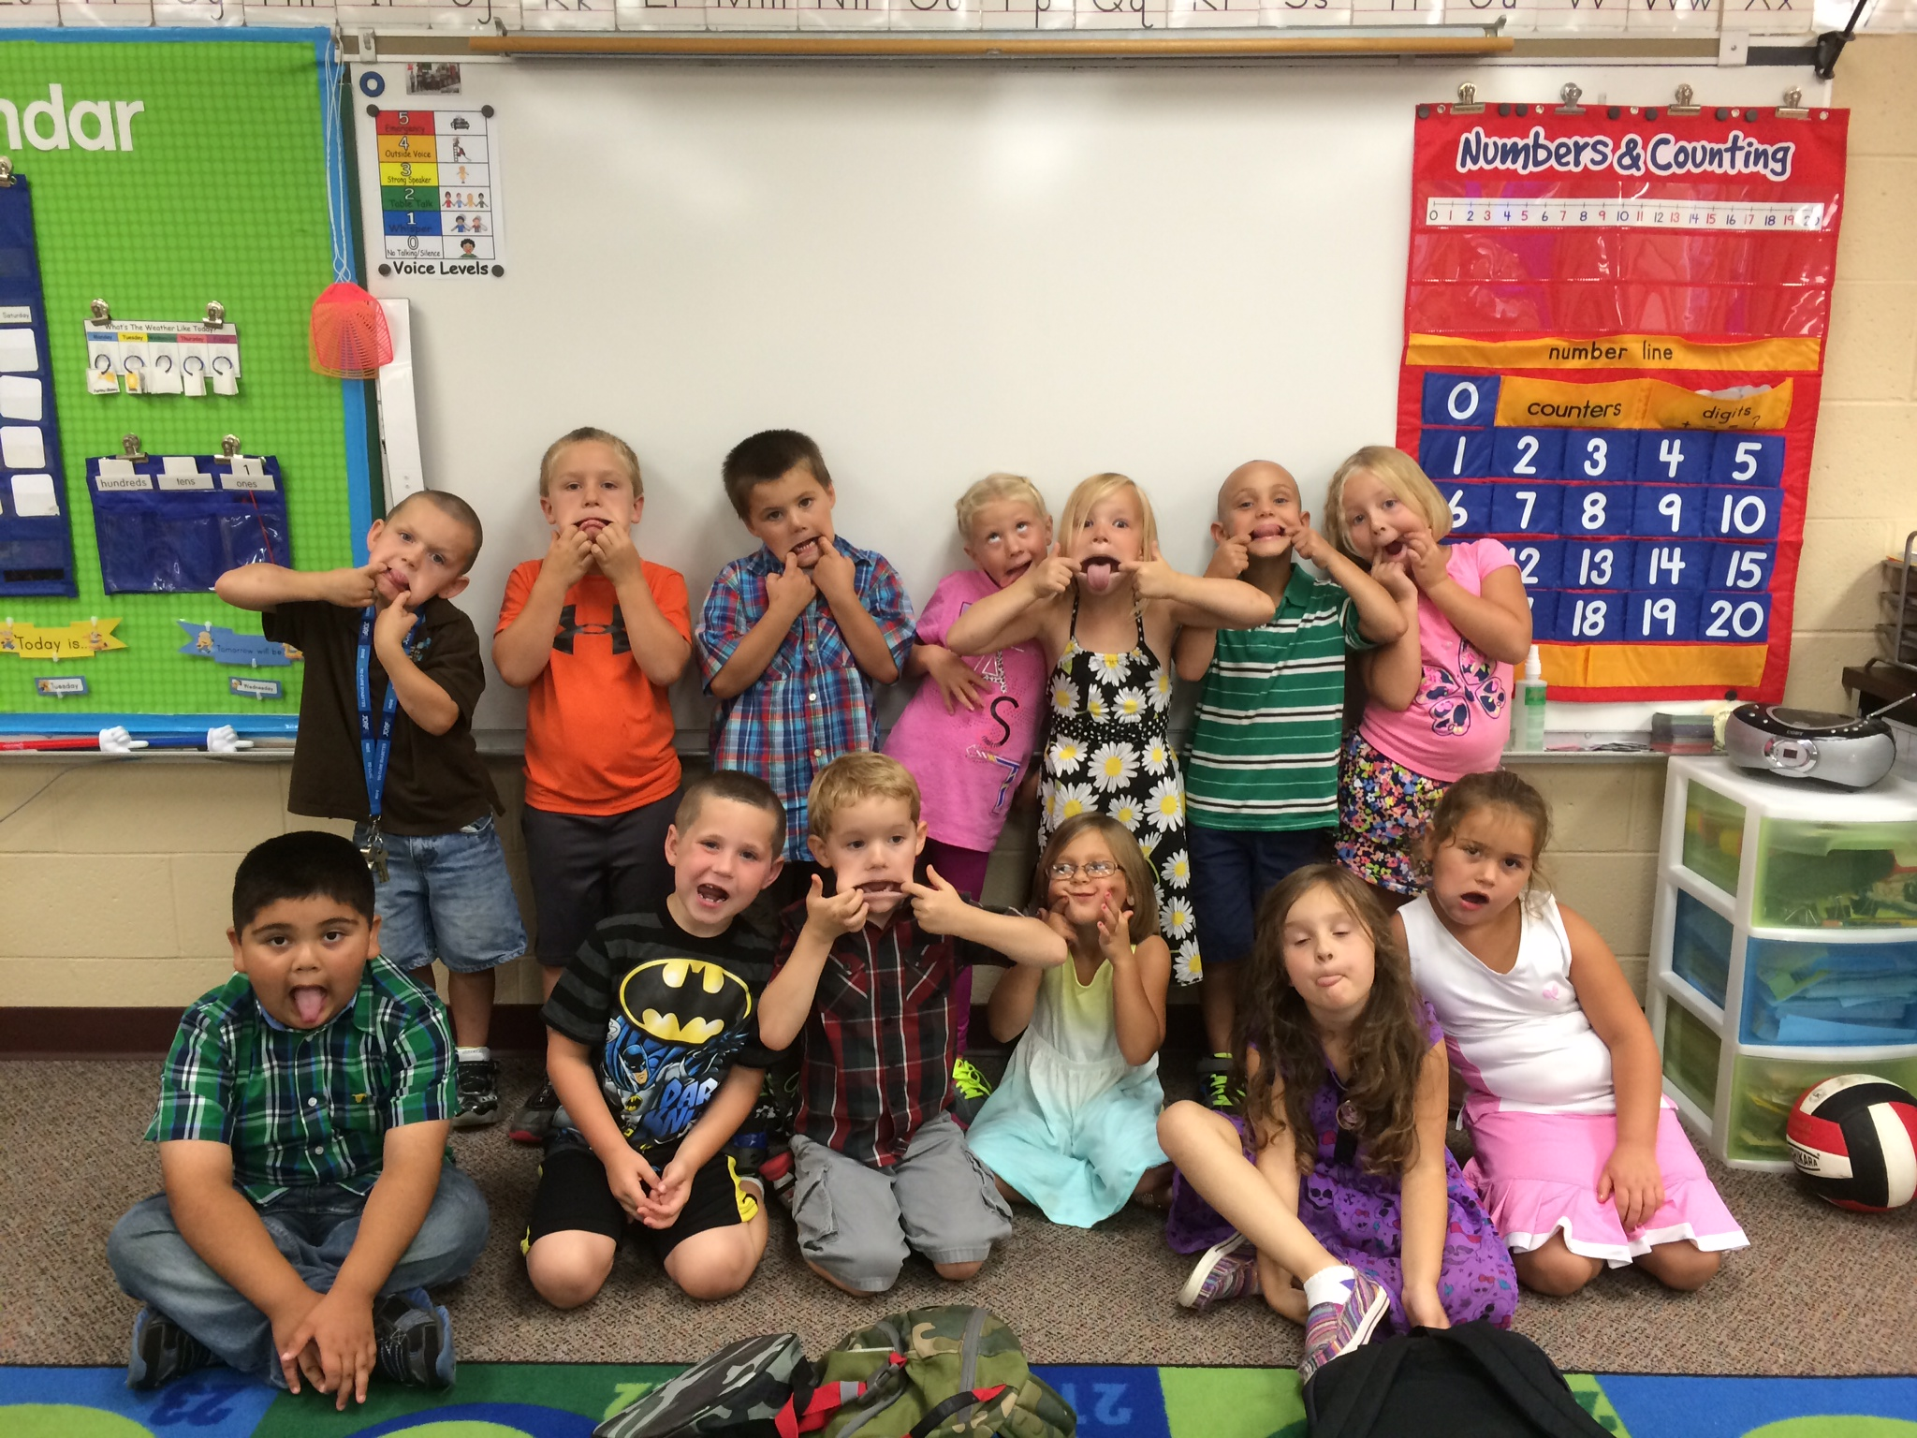

Early Release for students. School will let out at 1pm.

October 8th

##### Early Release

Early Release for students. School will let out at 1pm.

* Please check your child’s folder on a nightly basis. I will check it every morning.
* I have a class website that I will do my best to keep up to date. There will be lots of information and pictures there.  
  cfkinderkiddos.weebly.com
* We will be taking a field trip to the apple orchard on Friday 19th. **Please sign and return the permission slip!**
* I have attached a letter showing the letters that your child is unfamiliar with. Please practice these letters at home. Knowing these letters will making reading and writing a lot easier when we dive further into them!

This week we began our word and letter study. We started with the word ‘the’ and the letter ‘Ss’. Your child should be able to read and write both the letter and the sight word! We learned 1 part of our Daily 5: Read to Self. We also started learning how to correctly write the numbers 1-5. We are really getting the routines down this week, which will make the rest of the year a breeze!

Next week we will learn the letter ‘Aa’ and the sight word ‘my’. We will learn another part of our Daily 5 and continue counting and writing numbers. We will also be learning about apples and ending the week with a trip to the apple orchard!

# What’s New in Kindergarten?

Ms. Quick’s Class

Kindergarten

September 2014

Apple Orchard trip to LaPacek’s in Poynette.

September 19th

September 25th

##### Field Trip

##### Early Release

#### Upcoming Dates

### Announcements