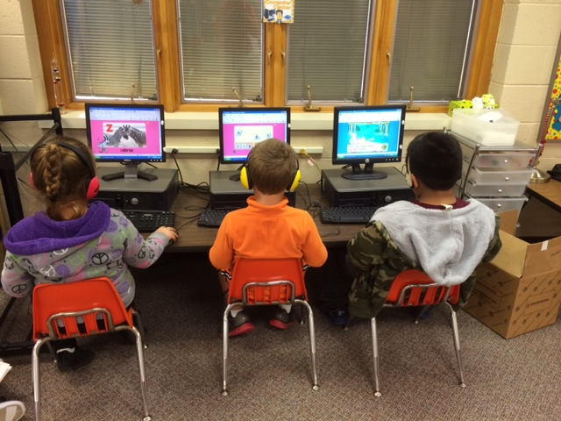

Parent-Teacher conferences from 4-8pm

October 9th

##### Conferences

Early Release for students. School will let out at 1pm.

* Please check your child’s folder on a nightly basis. I will check it every morning.
* I have a class website that I will do my best to keep up to date. There will be lots of information and pictures there.  
  cfkinderkiddos.weebly.com
* There is an Early Release scheduled for Thursday 25th. Students will be dismissed at 1pm.
* Parent-Teacher Conferences are scheduled for October 9th from 4-8. This will also be the day your child can have his/her school picture retaken.

This week we took a look at the letter Aa and the sight word my. The class used their 2 new sights words in their writing this week (this was very exciting for them!) We finished our first chapter in the math series and learned the terms ‘greater than’ and ‘less than’. In science we learned about the parts of an apple and how apples grow. We also tried 3 different colored apples and made our very own applesauce. I have attached the recipe because they loved it so much.

Next week we will learn the letter ‘Tt’ and the sight word ‘that’. We will learn another part of our Daily 5 and continue counting and writing numbers. We will also be learning about Fall this week and taking a look at the leaves.

# What’s New in Kindergarten?

Ms. Quick’s Class

Kindergarten

September 2014

Early Release for students. School will let out at 1pm.

September 25th

October 8th

##### Early Release

##### Early Release

#### Upcoming Dates

### Announcements