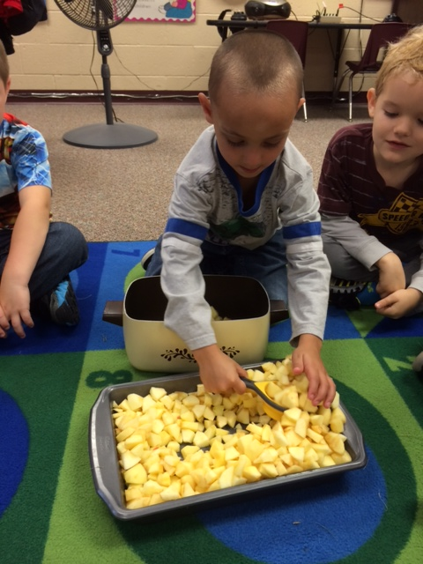

Early Release for students. School will let out at 1pm.

* I have a class website that I will do my best to keep up to date. There will be lots of information and pictures there.  
  cfkinderkiddos.weebly.com
* We will have a book fair in the Elementary Library the week of Conferences. We will take a walk through and I encourage you to stop by and check it out during Conferences!
* We will be doing the State-Wide mandatory PALS testing Oct 13-17. Please make sure your child gets plenty of sleep and breakfast each day during this time!
* Book Orders are due October 15th. You can order online or by filling out the flyer.

State-Wide PALS testing everyday this week.

October 13-17th

##### PALS Testing

Parent-Teacher conferences starting at 4.

This week we worked on the letter ‘Ii’ and the sight word ‘and’. We worked on stretching out words and sounding out –at family words. This was hard for those who are still unsure about letters and letter sounds so keep practicing!! In math we took a look at the numbers 6-10. In Science we learned about cows, pigs and sheep. We will learn about chickens, and horses next week.

Next week we will learn the letter ‘Pp’ and the sight word ‘is’. We will learn the last part of our Daily 5 and continue counting and writing numbers. We will also be learning about the farm this week. Please look for the PALS information flyer in your child’s folder. We will be talking about it more next week.

Conference times should be coming home soon. If your time doesn’t work for you, please let me know and we can try to reschedule it.

# What’s New in Kindergarten?

Ms. Quick’s Class

Kindergarten

October 2014

October 8th

October 9th

##### Early Release

##### Conferences

#### Upcoming Dates

### Announcements