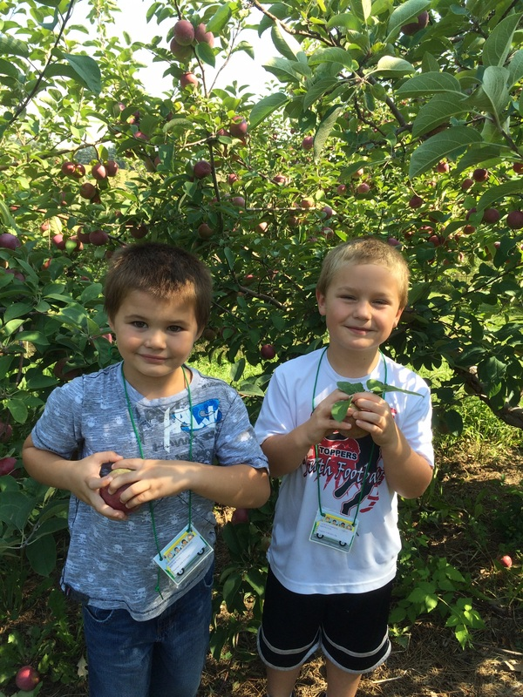

Early Release for students. School will let out at 1pm.

State-Wide PALS testing everyday this week.

October 13-17th

##### PALS Testing

Parent-Teacher conferences starting at 4.

* Please check your child’s folder on a nightly basis. I will check it every morning.
* I have a class website that I will do my best to keep up to date. There will be lots of information and pictures there.  
  cfkinderkiddos.weebly.com
* We will have a book fair in the Elementary Library the week of Conferences. We will take a walk through and I encourage you to stop by and check it out during Conferences!
* We will be doing the State-Wide mandatory PALS testing Oct 13-17. Please make sure your child gets plenty of sleep and breakfast each day during this time!

This week we worked on the letter ‘Tt’ and the sight word ‘that’. We worked on counting syllables and hearing and recognizing rhyming words and beginning sounds. In writing we worked very hard on stretching words to write. This was hard for those who are still unsure about letters and letter sounds so keep practicing!! In math we took a look at the numbers 6-10. In Science we learned about fall, scarecrows and leaves.

Next week we will learn the letter ‘Ii’ and the sight word ‘and’. We will learn another part of our Daily 5 and continue counting and writing numbers. We will also be learning about the farm this week and next week!

# What’s New in Kindergarten?

Ms. Quick’s Class

Kindergarten

September 2014

Apple Orchard trip to LaPacek’s in Poynette.

October 8th

October 9th

##### Early Release

##### Conferences

#### Upcoming Dates

### Announcements